% Carlos Lazo

% ECE 503

% Homework #9

% Due: 3/29/10

function b = HW09_lpfir(M, cutoff)

N = 100;

% Find the index at which the cutoff should occur.

ind_cut = ((cutoff) / pi) * N;

% Set all values up to that cutoff = 1 to mimic the lowpass filter.

H = zeros(1, N);

H(1:ind_cut) = 1;

% Add in linear phase.

H(1:ind_cut) = H(1:ind_cut) .* ((-1) * ((M-1)/2) * ((2*pi*(1:(N/2))) / N));

H(ind_cut + 1 : N) = H(ind_cut + 1 : N) .* (((M-1)/2) * (2*pi/N) * (N - (ind_cut + 1 : N)));

% Take the IDFT of the sequence created.

h_n = ifft(H,N);

% Truncate the given sequence.

h_n_trunc = h_n(1:M);

m = (1:M);

% Generate the Blackman Window of length M.

b_win = 0.42 - 0.5*cos((2*pi*m)/(M-1)) + 0.08*cos((4*pi*m)/(M-1));

% Multiply the truncated IDFT by the Blackman Window function

% to get the desired filter coefficients.

b = h_n_trunc .* b_win;

% Carlos Lazo

% ECE 503

% Homework #9

% Due: 3/29/10

%% 2) MATLAB Programming and Filter Comparison

clear all; close all; clc;

% a. LPFIR Design

M = 20;

cutoff = pi/2;

b = HW09_lpfir(M,cutoff);

[H, w] = freqz(b, 1, 1024);

figure;

subplot(2,1,1);

plot(w,abs(H));

xlabel('Frequency in radians');

ylabel('Magnitude');

title('Lowpass Filter');

grid on;

subplot(2,1,2);

plot(w,angle(H));

xlabel('Frequency in radians');

ylabel('Phase');

title('Lowpass Filter');

grid on;

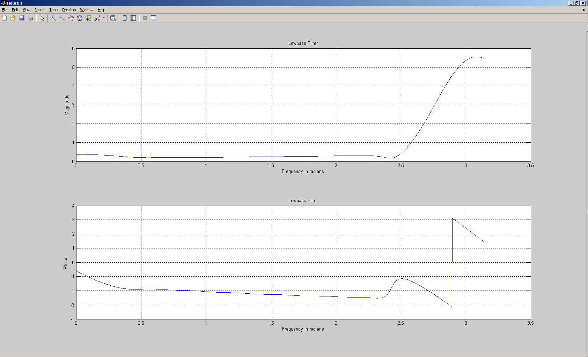

%% 2) MATLAB Programming and Filter Comparison

clear all; close all; clc;

% b. FIRPM Function Development

N1 = 5;

N2 = 7;

N3 = 9;

N4 = 11;

b1 = firpm(N1-1, [0 .5 .75 1], [0 0 1 1]);

b2 = firpm(N2-1, [0 .5 .75 1], [0 0 1 1]);

b3 = firpm(N3-1, [0 .5 .75 1], [0 0 1 1]);

b4 = firpm(N4-1, [0 .5 .75 1], [0 0 1 1]);

[H1, w1] = freqz(b1, 1, 1024);

[H2, w2] = freqz(b2, 1, 1024);

[H3, w3] = freqz(b3, 1, 1024);

[H4, w4] = freqz(b4, 1, 1024);

figure;

subplot(2,2,1);

plot(w1,abs(H1));

xlabel('Frequency in radians');

ylabel('Magnitude');

title('Highpass Filter #1');

grid on;

subplot(2,2,2);

plot(w2,abs(H2));

xlabel('Frequency in radians');

ylabel('Magnitude');

title('Highpass Filter #2');

grid on;

subplot(2,2,3);

plot(w3,abs(H3));

xlabel('Frequency in radians');

ylabel('Magnitude');

title('Highpass Filter #3');

grid on;

subplot(2,2,4);

plot(w4,abs(H4));

xlabel('Frequency in radians');

ylabel('Magnitude');

title('Highpass Filter #4');

grid on;

